Phase 1-Brainstorming & Ideation

Problem: Employee information received in Excel needs to be imported into ServiceNow efficiently Without manual entry.

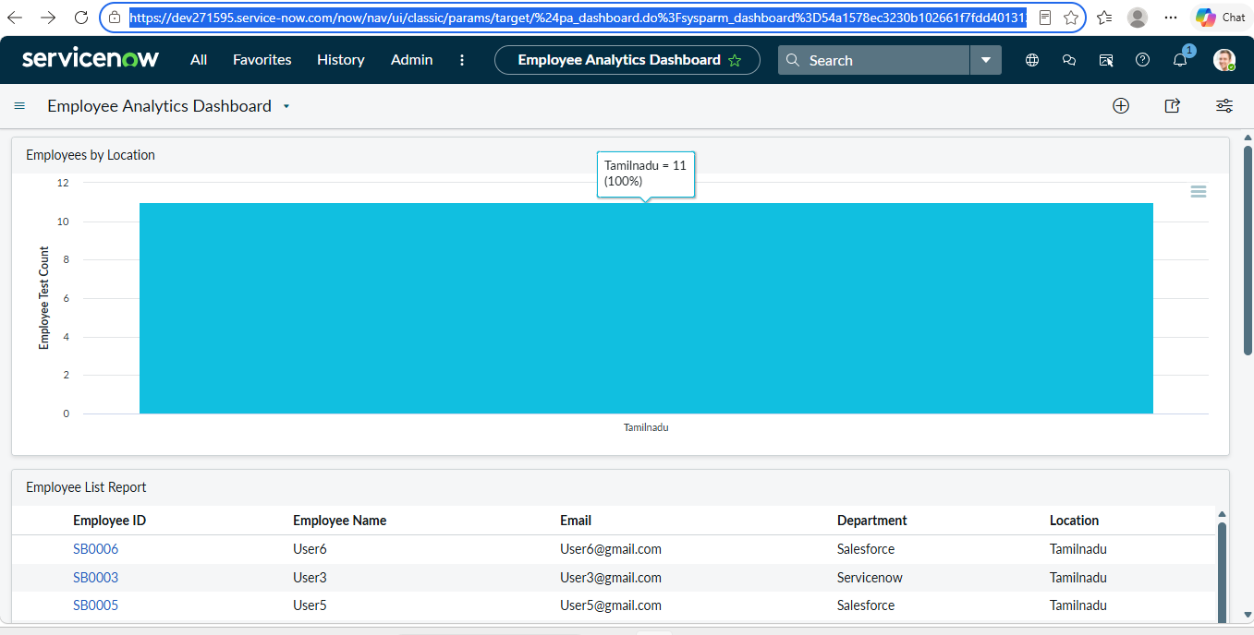

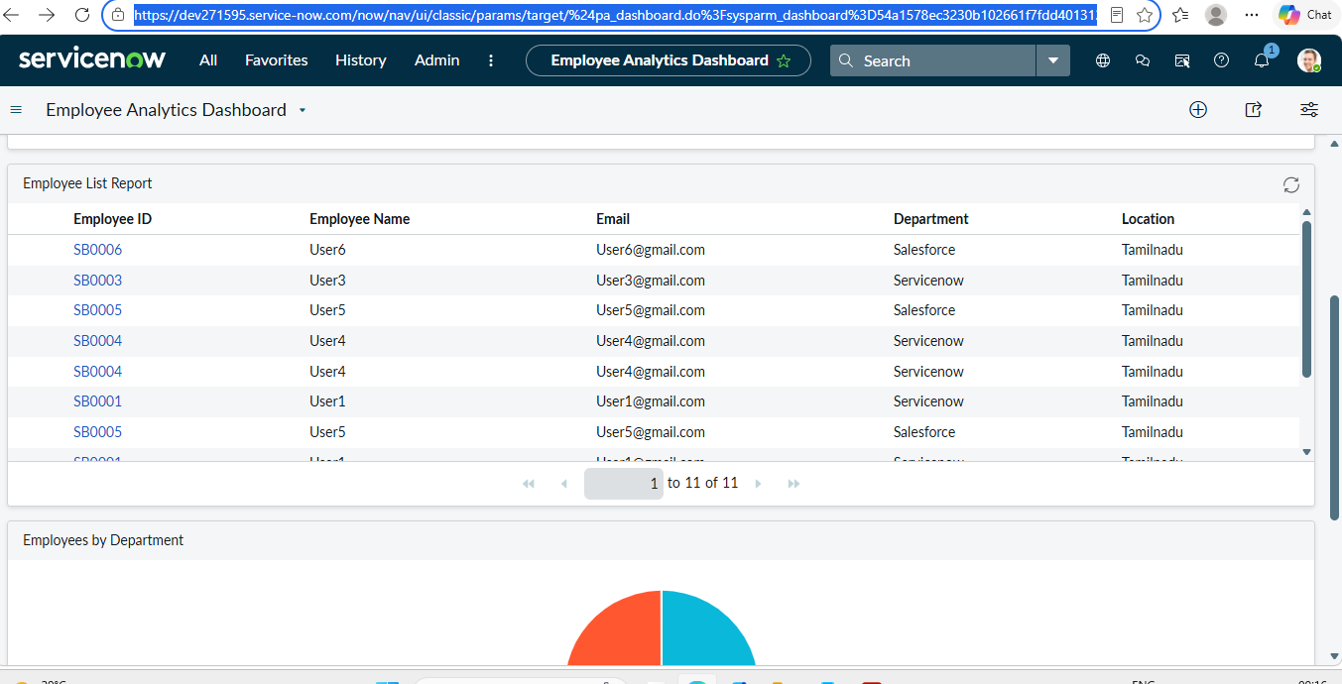

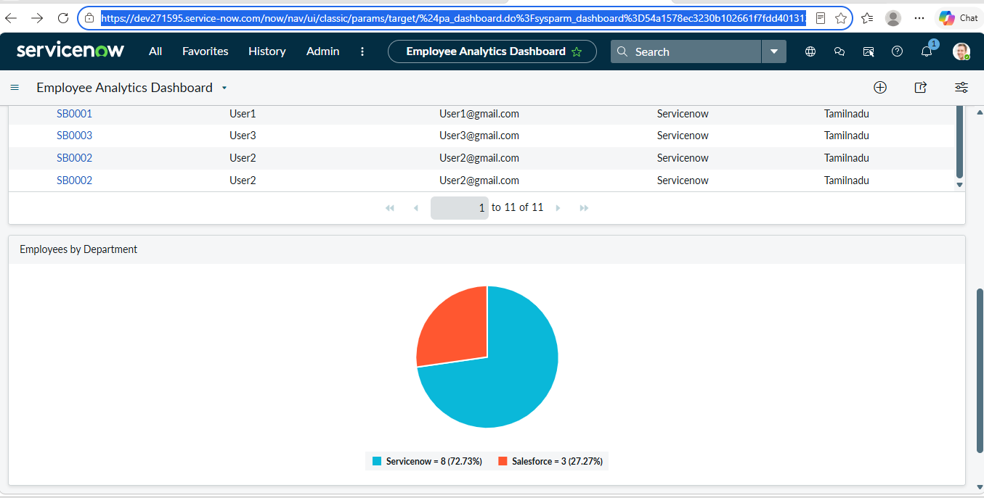

Idea: Use ServiceNow Import Sets and Transform Maps to automate employee data migration.

Phase2-Requirement Analysis
*Excel employee data
*ServiceNow platform
*Employee target table
*Import Set
*Transform Map
*Coalesce
*Reports
*Dashboard

Phase3-Project Design
*Excel File
*Import Set Table
*Transforms Map
*Field Mapping
*Coalesce
*Employee Test Table
*Reports
*Dashboard

Phase4-Project Planning
*Prepare Excel data
*Create ServiceNow table
*Create Import Set
*Create Transform Map
*Map fields
*Enable Coalesce
*Test import/update
*Create Reports
*Create Dashboard
*Prepare documentation/demo

Phase5-Development
*This is Where you put the actual implementation screenshots. You document already provides these steps.
Phase6-Testing

Test case | Expected Result | Result
Import new employee | New record created | pass
Import existing Employee ID | Existing record update | pass
Upload same file again | Duplicate records not created | pass
Check Department report | Correct employee count displayed | pass
Check Dashboard | Reports displayed correctly | pass

Phase7-Documentation put:
*Introduction
*Problem statement
*Objectives
*Requiremente
*Design
*Development
*Testing
*Screenshots
*Result
*Conclusion

